Arduino Lesson 3
PWM LED Brightness Control
- Intro
Pulse Width Modulation(PWM) is a kind of method of analog signal level for digital encoding, We have to use high resolution counter, by using square wave duty ratio to encodes a specific analog signal level as computer unable to output analog voltage, only 0 or 5 v digital voltage value . PWM signal are still numbers. Because in any given moment, amplitude of the dc power supply is either full 5v (ON), or 0v (OFF). Voltage or current source is a pass (ON) or OFF (OFF) to repeat pulse sequence added to the simulative load. DC supply addedto load when it is on. DC supply stop when it is off. As long as enough bandwidth, any analog value can use PWM coding. The output voltage value is calculated through the on and off time

Output voltage = (turn on time/pulse time) * maximum voltage value
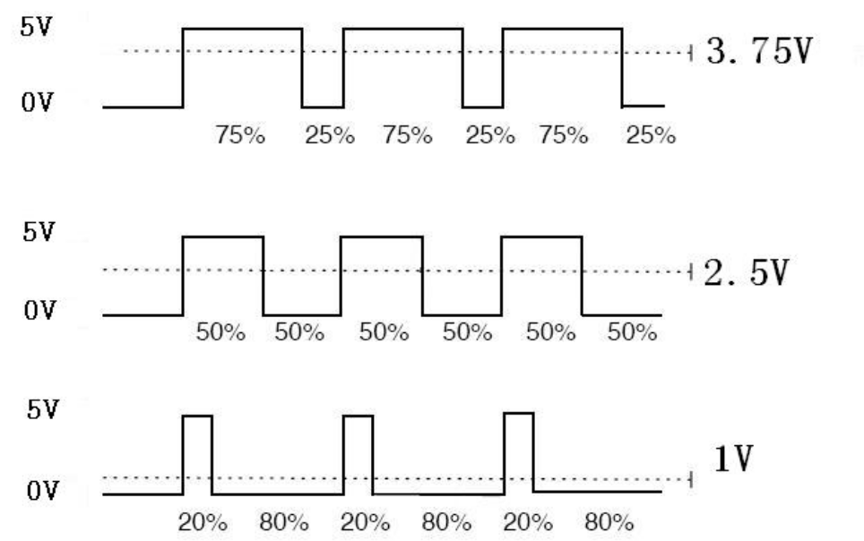
PWM can be used on lots of applications such as adjust lighting brightness, motor speed, sound making etc.

Here are the PWM basic parameters.
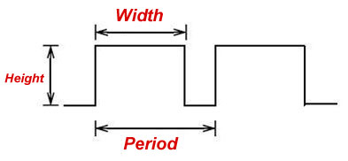
1、Variations in pulse width (minimum/maximum)
2、pulse cycle (1 seconds pulse frequency number reciprocal)
3、voltage level (for example: 0 v to 5 v)
- Connection
Arduino has 6 PWM interface, they are #3、#5、#6、#9、#10、#11，Last lessons we have done the experiment by using push button to control led,which means Digital signal control interface,and we do the experiment with potentiometer. Now we use potentiometer to control the led.
Parts required:
Potentiometer x 1
Red 5mm LED x 1
220ΩResistor x 1
Breadboard x 1
Jumper wires x 1 Bundle

Connect the Potentiometer ( the analog input) to analog interface, LED interface to PWM interface, so through different PWM signal led will have different brightness.
Connect them up as below.
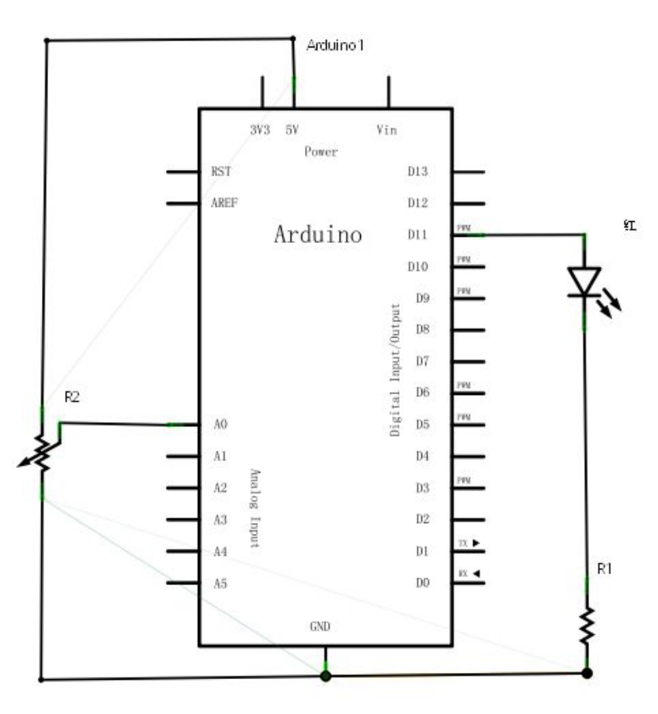
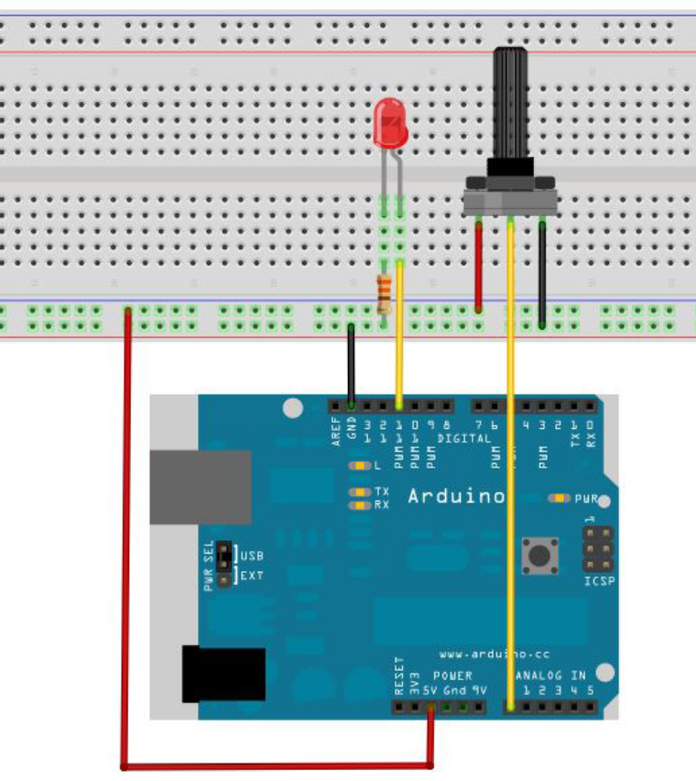
During programming, we will use analogWrite(PWM interface，analogue value) function，in this experiment the signal of analogue value is assigned to the PWM interface to make the led brightness change, then read on the screen where shows the analogue values.This means we just have one more step(assign analogue value to PWM interface) than the analogue value reading experiment.

- Program for reference.
int potpin=0;//Define analogue interface.#0
int ledpin=11;//Define digital interface #11.(PWM output) int val=0;// temporary storage the Variable value from the sensor
void setup()
{
pinMode(ledpin,OUTPUT);// Define digital interface #11 as output
Serial.begin(9600);//Setup Baud rate as 9600
// Note: analogue interface default setup is input.
}
void loop()
{
val=analogRead(potpin);// Read analogue value from sensor and assign to val
Serial.println(val);//Show val variable.
analogWrite(ledpin,val/4);// Turn on LED and set up brightness(PWM max.output value 255)
delay(10);//Delay 0.01 sec.
}
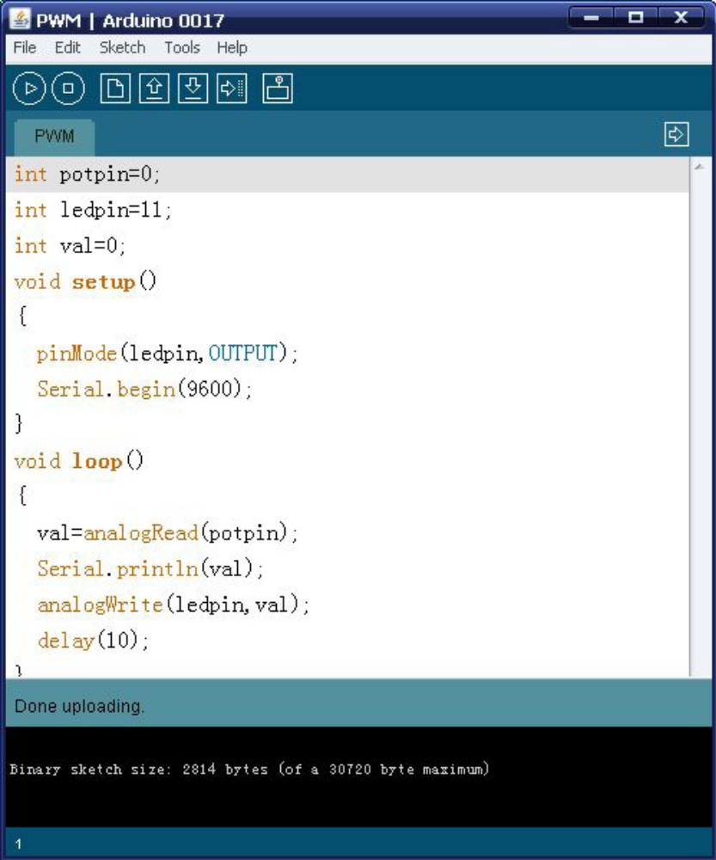
Download the program, the values on screen will keep changing and the LED brightness change at the mean time when you rotate the potentiometer knob.

